NHSA Health-Tech Programme Call for Proposals

The Israel Innovation Authority (IIA) and the Northern Health Science Alliance (The NHSA) invite interested Israeli companies to submit applications to pilot and or co-develop healthcare-related technology solutions with NHSA members.
The NHSA and the IIA are seeking to advance healthcare by helping Israeli companies get the evidence and assistance they need to fine-tune their development and to enter and be successful in the British healthcare market.
NHSA members would serve as a real-world living laboratory for the Israeli companies to test and improve an existing process, service, or product; or to apply a new process to health care for the first time.
In addition, NHSA members can proivide consultancy advice to support UK market entry, including hte legal and regulatory environment, evidence generation, business case development and assistance in commercialisation.
The goal of this collaboration is to accelerate the availability of medical innovations to the public, introduce Israeli healthcare technology to Europe, and advance the development and deployment of discoveries for the benefit of patients everywhere.

The IIA provides resources to aid technology advancement for Israeli companies.
The NHSA provides expertise and excellence in clinical care, clinical studies, and R&D activities. The NHSA is a health and life sciences partnership between the leading NHS trusts, universities and Academic Health Science Networks in northern England. The NHSA was established in 2011 with a mandate from our member organisations to act, and add value, across research and innovation in the North.
We work together with our members, industry and Government to mobilise the North’s assets for the benefit of the people and the economy. We do this by brokering research collaborations, building expert networks, attracting investment, and providing a unified voice for the region’s health research system.
The NHSA partnership is made up of 24 members: 12 NHS trusts, including two specialist Metal Health Trusts, 12 world leading universities and four Academic Health Science Networks (AHSNs). Collectively they serve a population of 16 million people. Our 12 NHS Trusts employ 150,000 staff and turn over £6 Billion annually. Our Universities train 130,000 health and life science graduates, brining ing more than £1.25 billion of research income and the AHSNs work with over 1,000 companies to acheive market access in the UK.

Each NHSA member Hospital Trust participating in this call has described its offer and specialist health themes over the next pages. When submitting an expression of interest, please indicate which organisation you feel is the best fit for your company, however, all Expressions of interest will be reviewed by a multi-disiplinary panel drawn from across our member organisations to ensure the best opportunity for matching partners, and where beneficial, identify opportunities to work with multiple organisations to provide access facilities, expertise or multi-site trials.
The NHSA Academic Health Science Network (AHSN) Members exist to support the uptake of innovative products and services into the NHS. They offer a range of support services from providing an introduction to the NHS as a market and the funding landscape, through to in-depth business model and case development. Lead NHS Trusts will broker introductions and access to AHSN as relevant during the project planning phase.

Website: https://www.thenhsa.co.uk/

The health themes of interest to all NHSA members:
- Alleiviating post covid waitlists
- Diabetes
- Cancer
- Cardiovascular disease
- Imaging technologies
- Virtual wards
- Heath technologies for acheiving net zero

Individual member specialisms are described below:
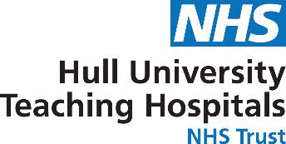
Hull University Teaching Hospitals Trust (HUTH) is situated in the geographical area of Kingston upon Hull and the East Riding of Yorkshire. Trust employs 8,356 staff, have an annual turnover of £794m (2021/22) and operate from two main sites - Hull Royal Infirmary and Castle Hill Hospital – whilst delivering a number of outpatient services from locations across the local health economy area.

Health Themes we are interested in:
- Virtual ward model to enable remote management of patients, supported by technology such as remote monitring apps, medical devices and platforms to communicate.
- Mobile healthcare technology solutions and applications including innovative medical devices (wearables)
- Rehab support – Develop innovative solutions to support rehab enabling earlier discharge of patients and remote models of care. This would include wide spectrum of solutions ranging from virtual reality platforms for brain injurty rehab to physical exercise apps to support from the pre-operative stage for elective pathways.
- Clinical Radiology – Department performs around 500,000 examinations each year. Department is technologically driven and has pioneered AI for stroke diagnosis and treatment (Rapid AI) in routine clinical practice. Key areas of interest for further development in AI would be around,
  - Robotics
  - Natural language processing
  - Machine vision

- Transforming care through Simulation – The Hull Institute of Learning and Simulation, located within HUTH campus excels in providing clinical skills and simulation training for health care professionals across the region & nationally. Interested in developing innovative solutions to support training & care delivery including highly specialised 3D anatomical printing and voice recognition packages in clinical settings.
- Referral management – Developing decision support tools for closer working with Primary Care physician for enabling appropriate referrals.
- Trust’s planis to become net zero by 2030 and new solutions developed would be aligned with the sustainable strategy of the Trust.

More Information: Hull Additional Info here>>>
Webite: https://www.hey.nhs.uk/

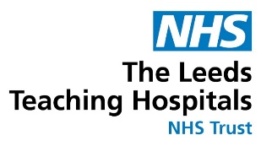
Leeds Teaching Hospitals NHS Trust is one of the largest NHS Trusts in the UK, with an annual budget of over £1.3bn and >18,000 staff. It serves a population of more than 5m people from a wide range of different ethnic and social backgrounds across Leeds and the wider North of England, sees more that 1.2m patients annually and is a world-renowned centre for highly specialist clinical services and research. It is consistently one of the top performing hospitals for deliverying clinical research, recruiting over 20,000 patients into research each year.
A major driver for innovation at the Trust is the construction of 2 new hospitals - one adult hospital and a brand new Children’s hospital which are due to open in 2026/7.

We are interested in health innovation across multiple different clinical areas including (but not limited to):
- Oncology
- Haematology
- Cardiovascular
- Diabetes
- Musculoskeletal
- Surgery
- Ophthalmology
- Dental
- Emergency Medicine
- Maternity
- Clinical Genetics
- Laboratory testing (blood tests, microbiology tests)
- Children’s Health
- Neurosciences

From a technology perspective, we are interested in:
- Artificial Intelligence
- Digital
- Medical Devices
- Advanced Therapies
- Diagnostics

More Information: Leeds Additional Info here>>>
Webite: https://www.leedsth.nhs.uk/

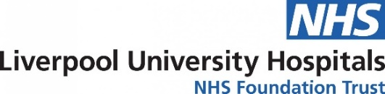

Liverpool University Hospital NHS Foundation Trust (LUHFT) is the 11th largest NHS Trust in the UK. It is the largest provider of adult acute and specialist healthcare in the city of Liverpool and receives secondary, tertiary and quaternary referrals for specialist treatment from the populations of Liverpool (~950,000) and Cheshire and Merseyside (~2.5 million) as well as North Wales and further afield.

LUHFT is a high-volume research active NHS organisation with aspirations to grow its research and innovation (R&I) profile to become a national leader. Central to this is the inclusion of R&I as one of the four pillars of its corprate strategy. Amongsta wide-ranging R&I portfolio, LUHFT boasts two centres of translational research excellence which we believe are ideally suited to this call:

- Liverpool Head and Neck Centre
- Clinical Eye Research Centre

Health Themes of interest to us are:
Head and Neck Centre (https://livheadandneck.co.uk/) areas of speciality expertise:
- Pre-malignancy
- Oropharynx cancer, especially Human papillomavirus related oropharynx cancer
- Oral cavity cancer
- Function-sparing, especially transoral, surgical approaches which we have pioneered in the UK
- Tumour Immunology and Immunotherapy
- Speech and Language Therapy
We would welcome approaches from companies who may have technologies which would enhance our research capabilities in the below areas:
- Whole Genome Sequencing
- Transcriptomics
- Proteomics
- Metabolomics
- Multiplex IHC
- RNA ISH
- AI/Machine Learning, particularly as applied to radiology and digital pathology
- Surgical technology e.g. labelled nanoparticles for tumour / tumour margin detection or robotic technology to aid transoral surgery

Clinical Eye Research Centre (https://bit.ly/3BvRtOo)
We would welcome approaches from companies who may have technologies which would enhance our research capabilities in areas of existing research strengths. Technologies which might be attractive (but not exclusively so) include:

  - AI and DL sytems for ophthalmic images
  - Oculogenomics
  - Oculomics
  - Early detection and monitoring of ocular and systemic diseases

- More Information: Liverpool Additional Info here>>>
- Webite: https://www.liverpoolft.nhs.uk/

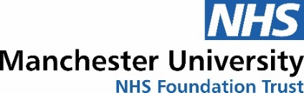

Manchester University NHS Foundation Trust (MFT) is one of the largest acute Trusts in the UK, employing over 20,000 staff. Comprising ten hospitals over seven separate sites, MFT provides a wide range of services from comprehensive local general hospital care through to highly specialised regional and national services.
MFT are looking for companies who are interested in collaboration opportunities with MFT to consult, generate clinical evidence, undertake clinical trials, co-develop and bring innovative technologies.
Challenge areas:
- Earlier detection/ intervention for cancer patients
- Data driven approaches to early diagnosis and pathway optimisation
- Innovative solutions to free up NHS resources and staff time:
  - Digital solutions to allow patients to take charge of their own health, monitor patients with chronic conditions from home, addressing digital literacy and digital exclusion.
  - Specifically in services which are overstretched, pathology, radiology, cancer. Solutions which can bypass these services or can translate results to be read by non-specialist clinicians.

Emerging areas for the Diagnostics and Technology Accelerator (DiTA):
- DiTA is focused on IVDs and MedTech in all disciplines
Specific areas of interest:
- Rapid POC and near patient testing for acute care settings.
    - Emergency medicine, acute surgery, acute cardiovascular, acute paediatrics
    - Innovations to address acute infection, antimicrobial resistance and promote good antibiotic prescribing
    - Genomics – innovative solutions which address a need for rapid identification of genetic variation e.g. pharmacogenetics, rare diseases.
  - Integrative diagnostics – the convergence of imaging, pathology, and laboratory tests with advanced informatics to revolutionise diagnosis and therapeutic management and free up NHS resources

More Information: Manchester Additional Info here>>>
Website: https://mft.nhs.uk/

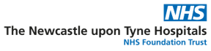
Newcastle upon Tyne Hospitals NHS Foundation Trust (NuTH) is one of the largest acute NHS Trusts in the UK employing over 18,000 staff. It serves the population of Newcastle upon Tyne, the North East of England and North Cumbria c. 3million people, and provides specialised healthcare services at a national and international level. NuTH has strong collaborative links with surrounding NHS organisations, Higher Education Institutions, including Newcastle University, national NHS and academic partners.

Health themes we are interested in:
- Discovery, development, evaluation and evidence for adoption generation for in vitro diagnostics
- Discovery and development of advanced therapeutics with particular emphasis on therapeutics in malignancy, liver disease and neuromuscular disease
- Diagnosis and management to improve quality of life in ageing and long term conditions
- Diagnosis and management of rare disease including advanced clinical trial design for rare and ultra rare disease
- Application of robotics to surgical intervention
- Development of genomic diagnostics and genomic medicine including mitochondrial genomics
- Reducing healthcare inequality through application of novel clinical pathways

More Information: Newcastle Additional Info here>>>
Website: https://www.newcastle-hospitals.nhs.uk/

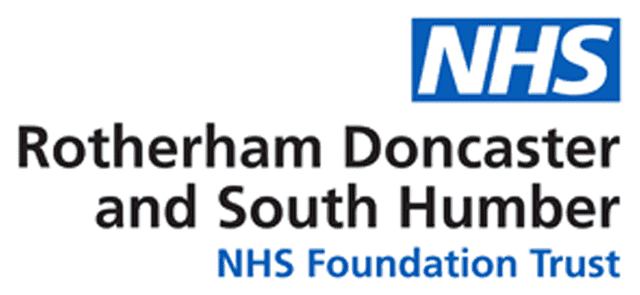
Rotherham Doncaster and South Humber NHS Trust is a mental health and community services organisation in the North of England. We employ circa 4,000 staff, and provide a diverse range of services for adults and children across three separate communities with around 200,000 patients.
The Grounded Research team is the Research and Innovation department of the Trust, and alongside the NHSA we are leaders of the mental health collaborative across the North of England - this includes all the NHS mental health Trusts, academic partners, and industry partners.
We have a strong track record in sponsoring, managing and delivering research and innovation. We have expertise in delivering large scale trials across the spectrum of mental health services, and a specific track record in psychological therapies, workforce wellbeing and burnout and biomarkers.
We run a dedicated community research facility, and in conjunction with the University of Sheffield have a state of the art psychotherapy and physiology lab, enabling EMG (Electromyography), ECG (electrocardiogram) and EDA (Electrodermal Activity) measurements alongside psychotherpay assessments.
Health Themes we are intereted in:
- Psychological therapies
- Workforce wellbeing burnout
- Epigenetics
- Biomarkers
- Decision support systems
- Medical Devices
- Medicines used in Mental Health
- Nutrition and its influence on behaviour
- Insights from data to support research and inform clinical care

More Information: RdaSH Additional Info here>>>
Website: https://www.rdash.nhs.uk/

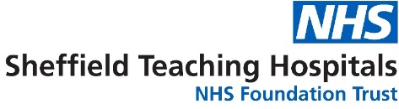
Sheffield is a thriving city in the heart of Great Britain with a track record for world class research and innovation in the field of healthcare and technologies. Sheffield Teaching Hospitals NHS Trust is one of the largest trusts in the country. The Trust manages 2 major adult hospitals as well as three specialist centres that cover dentistry, maternity and cancer, treating over 2 million patients annually with 18,000 staff.
An established partnerhsip with two world class universities – Sheffield University and Sheffield Hallam University - form the foundation for successful collaborations with industry and other partners.

Health themes we are interested in:
- Healthcare Technology and medical devices
- Sport research and increasing heathy lifespan
- Healthcare service design
- Neuroscience inc. Spinal Injuries, Dementia, parkinsons disease, motor neurone disease, stroke and multiple sclerosis
- Long term conditions inc. Neurological conditions, renal and diabetes
- Cancer treatments
- Gene Therapies
- Precision medicine – diagnostics and treatments.

More Information: Sheffield Additional Info here>>>
Website: https://www.sth.nhs.uk/

Application Process
Phase 1

Deadline for Expression of Interest (EOI) form submissions: 14/11/2022
The Israel Innovation Authority will invite selected Israeli companies to phase 2.

Phase 2
By 20/02/2023 the Israel Innovation Authority will invite selected Israeli companies to phase 2.
Deadline for full submissions: 21/06/2023

Supported activities may include: piloting, testing (of different kinds; including in real-world conditions), validation, trials, performance verification, device iteration, product and interface customization, pre-pilot activities, R&D activities needed for the pilot, optimizing the clinical use of a given technology/product, identifying the parameters of the product/technology and potential use cases, optimizing user interfaces, etc.

What support do the IIA and NHSA offer?

Successful Israeli applicant companies will receive funding from the Israel Innovation Authority. The Israel Innovation Authority can support R&D performing companies, registered and operating in Israel, with a grant of up to 50% of the approved R&D and Pilot Expenses Budget, according to its regulations and procedures. The Israeli companies must follow Israel Innovation Authority's rules and regulations, as described in the Hebrew website: https://innovationisrael.org.il/international/rnd

When a project eventually results in sales of a product, service, or process, the financial support must be repaid in royalties to the Israel Innovation Authority according to its regulations. In general, royalties are paid at rates beginning at 3% of sales, depending on various criteria. Royalties are payable until 100% of the amount of the grant has been repaid with interest as provided in the applicable regulations. If the project does not result in sales, no repayment is required.

The NHSA will provide some in-kind services, expertise, and/or use of facilities. Examples for such in-kind support can include:
- Usage of unique facilities for beta-sites operations;
- Access to real-field-conditions for the tested innovation;
- Usage of internal services, expertise, knowledge, or equipment;
- Access to unique data, data-sets, engines, devices, skills;
- Possibility to recruit patients, experimenters, tools, etc.;
- Experts' and consultants' time to guide, co-develop and, identify the parameters of the product/technology for testing or potential use cases;
- Regulatory and legal guidance to ensure full compliance;
- Assistance in co-commercializing the product; for example, through joint work with relevant local business partners (companies, investors, distributors, etc.) that are part of the NHSA network.

NHSA would fund its in-kind assistance for the project and make it accessible through an applicable agreement with the selected Israeli companies. In the case of a pilot project, where no IP is shared, up to 10% of the project budget could be used to pay the NHSA member for its services. In the case of a joint R&D project, where IP is shared, the costs of NHSA member could not be funded by the IIA.
An appropriate agreement between successful applicant companies and The NHSA member will need to be signed as one of the first milestones during the project initiation.

Process and Timeline
Program launch | September 2022
Deadline for submission of Expression of Interest (EOI) | 14/11/2022
Health centers select shortlisted companies, IIA invites shortlisted applicants to submit full application | 22/02/2023
Deadline for full IIA online application | 21/06/2023
IIA funding decision & project launch | September 2023

Contacts

NHSA  Dr. Ben Martyn  Cluster Development Manager  Ben.martyn@thenhsa.co.uk | Israel Innovation Authority  International Collaboration Division  InternationalCollaborations@innovationisrael.org.il

